DISHES | 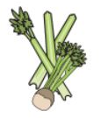 | 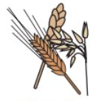 | 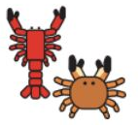 |  |  | 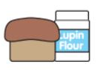 | 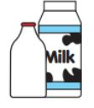   |  | 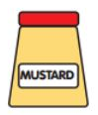 | 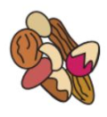 | 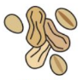 | 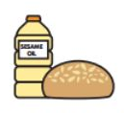 |  | 
 | Celery | Cereals containing gluten | Crustaceans | Eggs | Fish | Lupin | Milk | Molluscs | Mustard | Nuts | Peanuts | Sesame seeds | Soya | Sulphur dioxide
Vegetable Momos | ✓ | ✓ wheat |  | MC |  |  | MC |  | MC | MC | MC | MC | ✓ | MC
Sha Sha Chicken | MC | ✓ wheat |  | ✓ |  |  | MC |  | MC | MC | MC | MC | ✓ | MC
Dhal | MC | MC |  | MC |  |  | MC |  | ✓ | MC | MC | MC | MC | ✓
Chickpea and Spinach Curry | MC | MC |  | MC |  |  | MC |  | ✓ | MC | MC | MC | MC | ✓
Paneer and Butternut Squash Curry | MC | MC |  | MC |  |  | ✓ |  | ✓ | MC | MC | MC | MC | ✓
Cauliflower stir-fry | MC | ✓ wheat |  | MC |  |  | MC |  | ✓ | MC | MC | MC | ✓ | MC
Oatly Chai Tea ( vegan) | MC | ✓Oat |  | MC |  |  | MC |  | MC | MC | MC | MC | MC | MC
Chai Tea | MC | MC |  | MC |  |  | ✓ |  | MC | MC | MC | MC | MC | MC
Chilli Sauce | MC | ✓wheat |  | MC |  |  | MC |  | MC | MC | MC | MC | ✓ | MC
Beef / Chicken Stew | ✓ | ✓ wheat |  | MC |  |  | MC |  | ✓ | MC | MC | MC | ✓ | ✓
DISHES
 | Celery | Cereals containing gluten | Crustaceans | Eggs | Fish | Lupin | Milk | Molluscs | Mustard | Nuts | Peanuts | Sesame seeds | Soya | Sulphur dioxide
Mushroom Masala | MC | MC |  | MC |  |  | MC |  | ✓ | MC | MC | MC | MC | ✓
Vegetable Curry | ✓ | ✓ wheat |  | MC |  |  | MC |  | ✓ | MC | MC | MC | MC | ✓
Pork Stir-fry | MC | ✓ wheat |  | ✓ |  |  | MC |  | ✓ | MC | MC | MC | ✓ | MC
Vegan Cheese Cake |  | ✓ wheat  oat |  |  |  |  |  |  |  | MC | MC |  | ✓ | ✓
Chocolate Brownie |  | ✓ wheat |  | ✓ |  |  | ✓ |  |  | MC | MC |  | ✓
Mango Shake | MC | MC |  | MC |  |  | ✓ |  | MC | MC | MC | MC | MC | MC
MC- May Contain

